Workload Summary Report in Watermark

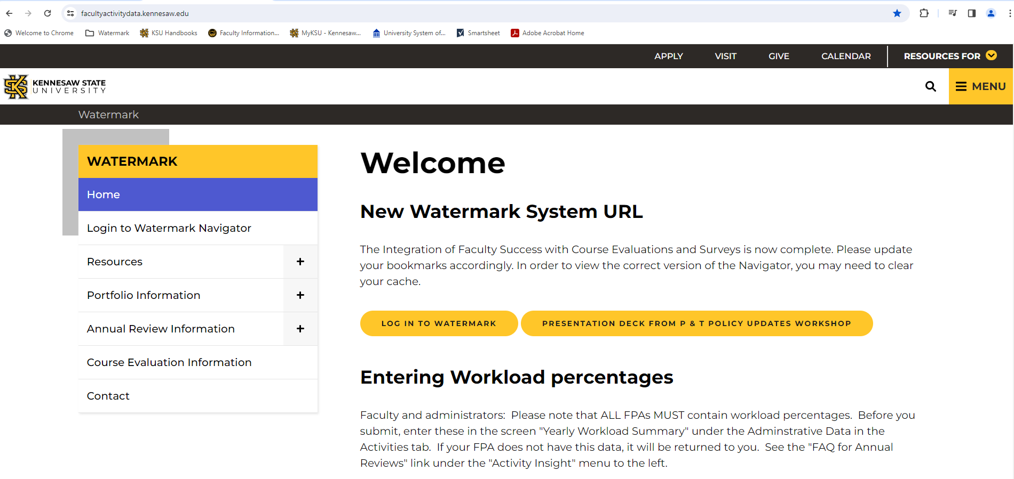

Log into Watermark through the Watermark home page: https://facultyactivitydata.kennesaw.edu

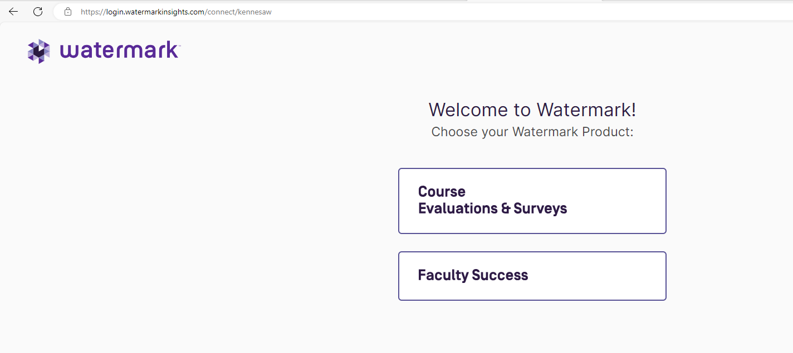

Click the Faculty Success box

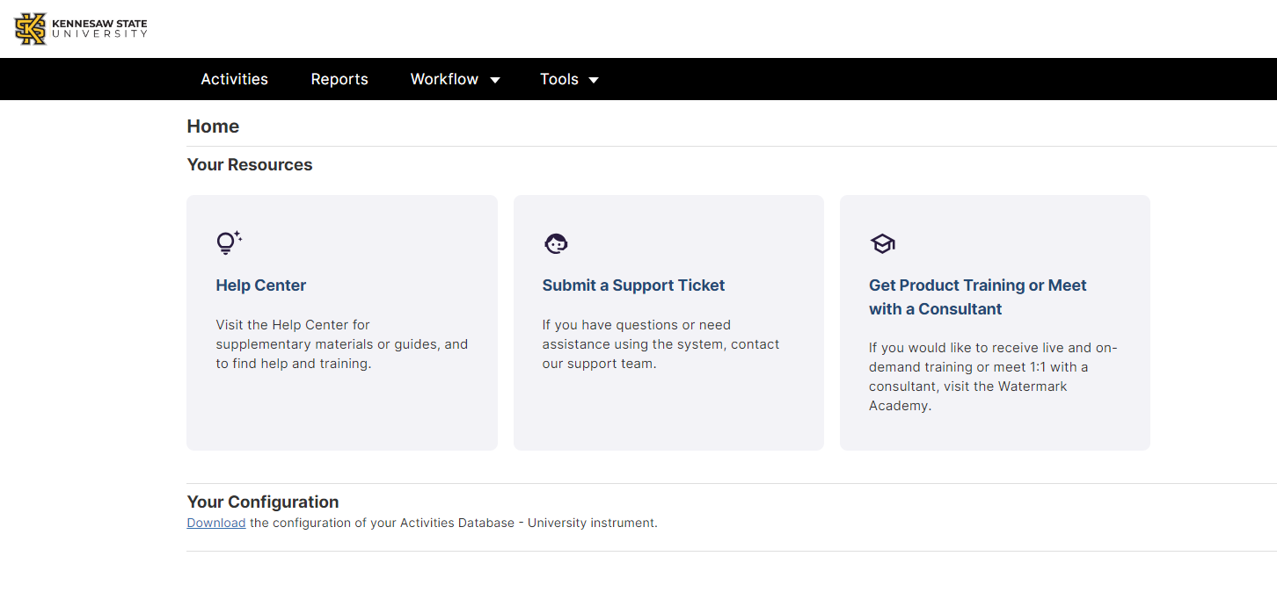
Click on Reports

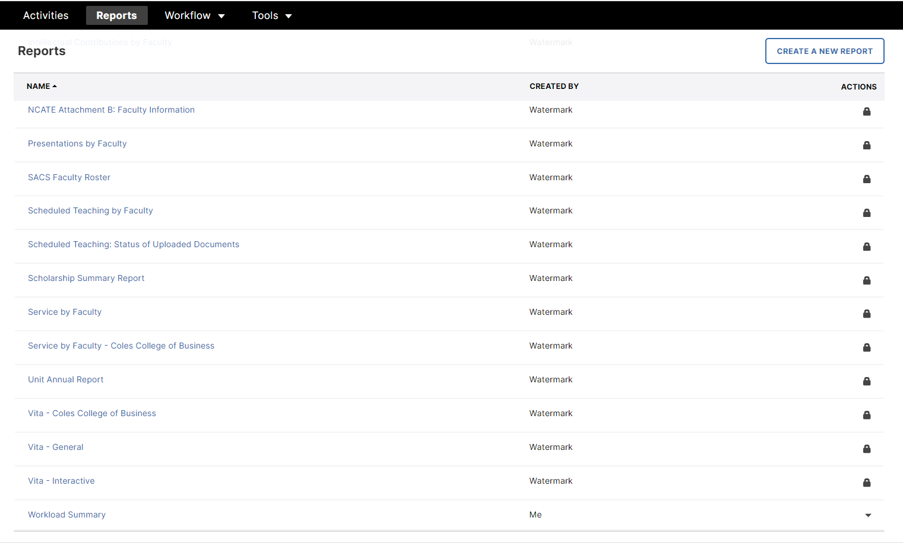

Scroll to the bottom of the Reports list and select ‘Workload Summary’

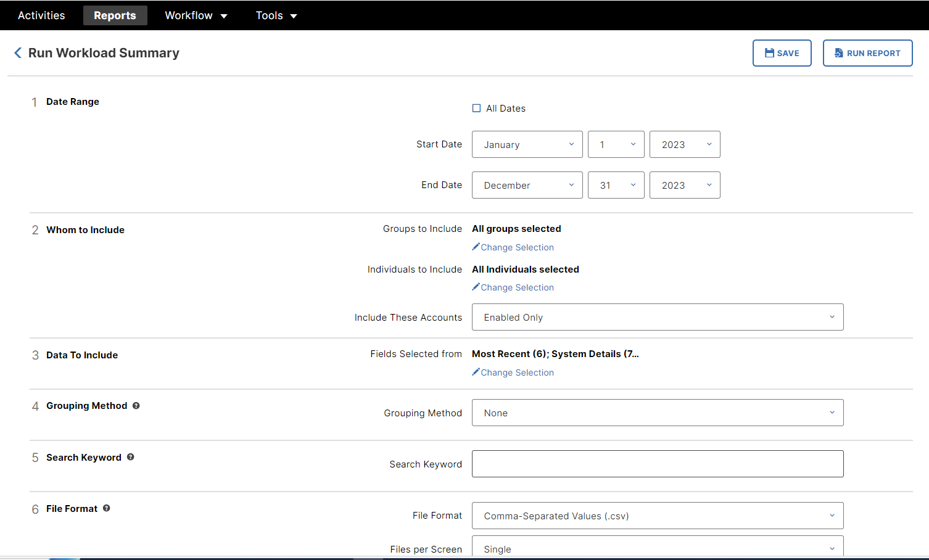

In the Whom to Include section, click the ‘Change Selection’ link in Groups to Include

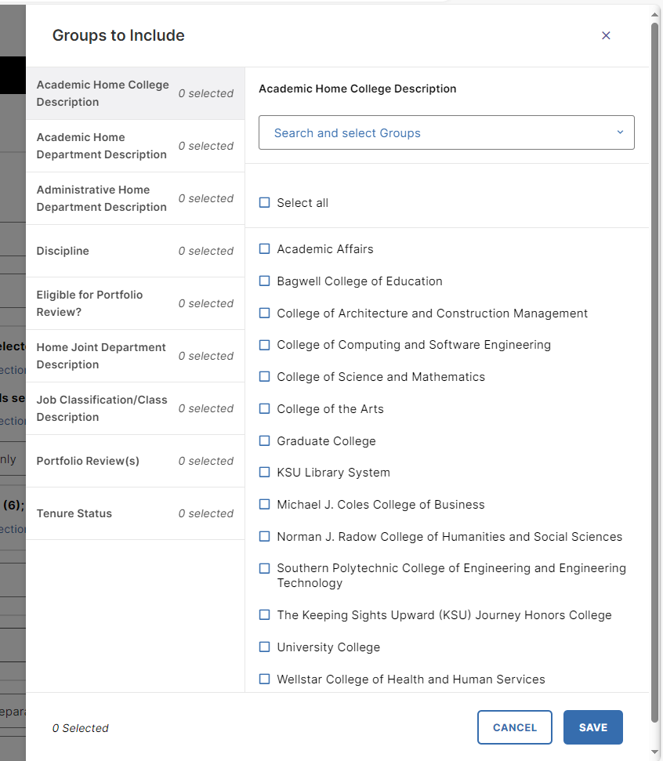
Select the appropriate college, or click ‘Academic Home Dept Description’ and choose a department(s)
Click ‘Save’

In the Data to Include section, click ‘Change Selection’
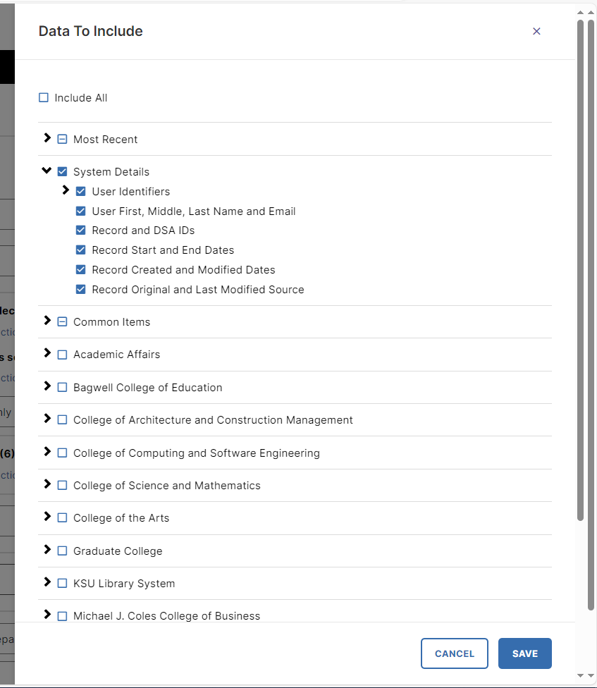
Click the black arrows to open the available data fields:

- A blue box with a check mark in it (for example, System Details) means all available data fields for
this group have been selected

- A box with a line through the middle of it (for example, Common Items) means some of the available
data fields for this group have been selected

** NOTE ** The Yearly Workload data box has already been selected in the Common Items section.

Click ‘Save’

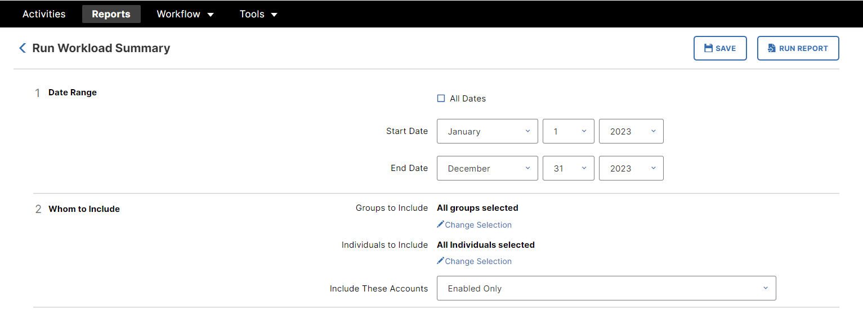

Update the beginning and end dates as needed

Click ‘Run Report’

